Usage Documentation for Teaching Center Video Processing Automation

A tool created by Brenden Sweetman

**Note from the Author:**

This is an automated process for encoding and combining lecture videos for the teaching center. Automation in general is to make your life easier, but please note a computer is not a human. You have to follow these directions exactly or the process will not work. Computers are not good at catching your errors. This tool **should** make life easier for you. If you are experiencing problems double check two things: where you put the files and how you named the file. If you are still having problems, contact me.

**Instructions:**

1. Insert SD card into computer
2. Open the “Teaching_Center_Video_Processing” folder on the desktop. This folder is your home base, everything you need is in this folder.
3. Drag the all of the mp4 files (and only the mp4 files) from the SD card into the *Copied* folder. Please make sure you do not put the video files in the *Done* folder (this is where we back up all the original files that have already been uploaded). You can and should process more than one class at a time just drag the files from each SD card into the *Copied* folder and name them appropriately.

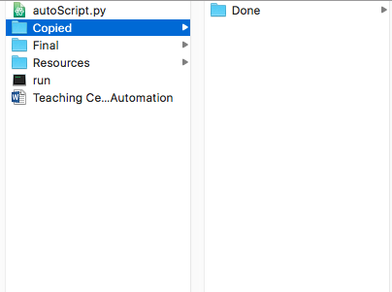

1. Rename the files according to the naming convention below. This is by far the most important step if you do not get this right the tool will not work!!!!

**Naming convention:**

Files MUST be named following this convention. This is the only way the script can recognize multi part files. If the name is off by even one character the script will not work, resulting in many different problems.

All movie video files have 5 mandatory parts delimited with "-":

1)Class

2)Professor

3)Year

4)Month

5)Day

Classes with 2 or more video files will have a 6th part denoting the order of the videos

The File naming convention is given below:

Class-Professor-Year-Month-Day-<part#>.mp4

NOTE: Do not use the “-” character for anything but separating the parts of the file name

Example file name for 1part video:

chem451-mabbs-2017-10-01.mp4

Example file name for multi-part video:

chem451-mabbs-2017-10-01-part1.mp4

chem451-mabbs-2017-10-01-part2.mp4

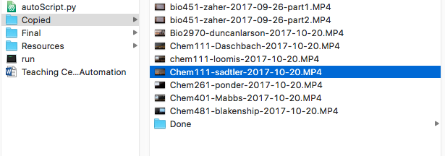Your *Copied* folder should look something like this:

**NOTE**: As seen in the example above the name of the class or professor can start with either a capital or lower case. With one exception: in multi-part videos the file names have to be **exactly** the same except for the part number. Try to be as consistent as possible with naming.

**ALSO NOTE**: The script will still run with bad names! The script will not catch all naming errors. Please double check the names before running the script!

1. Double check your names! (This is so important)
2. 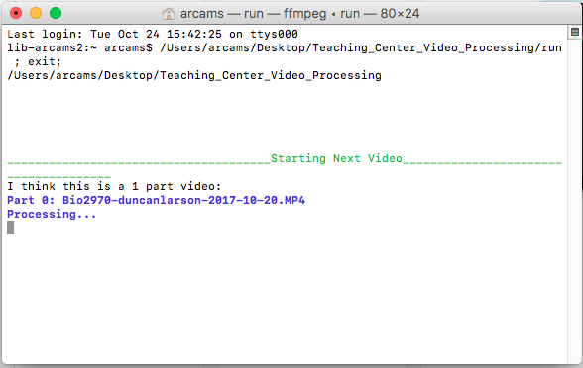Once you have double checked the names of the files you are ready to start the script. Double click the run executable. And watch the magic unfold! Ok it’s not that great but you should see a window like the one below that lets you know where in the process it is.

**NOTE**: Do not run two of these windows at the same time they will interfere with each other. Try and set up processing batches of more than one class throughout the day.

1. The window will let you know when it is done with one video and is moving on to another (see below). At this point you can upload the finished video. If you see any red text this means something went wrong with the names. If you see any text that is not green, red or blue the underlying process encountered an error (examples of these errors are given at the end of this document). If this happens double check that the input files are not corrupted. If you can’t figure it out process the video using handbrake and MP4 joiner and let me know something went wrong.

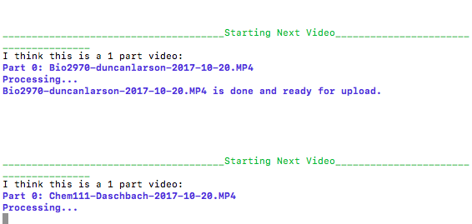

1. The window will let you know when it is done processing all of the videos. At this point you can close the window. All of the files that were in *Copied* should have been moved into the *Done* folder. If files are still in the *Copied* folder something went wrong. Check the output window for errors.
2. Upload the finished videos to box or blackboard as needed. Remember to give the videos a test run before uploading them.

**NOTE**: One common error is rearranging of multipart videos. Try and make sure that the order of multipart videos is conserved. AKA, make sure the video doesn’t start with the middle of the lecture.

**Examples of Errors and What to Do:**

* 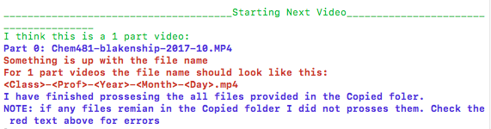Naming error caught by script: In this example the file name is missing the day. Go back and check that all parts of the naming convention are accounted for. Remember, the script will still run with bad names. The script will not catch all naming errors. Please double check the names before running the script!
* 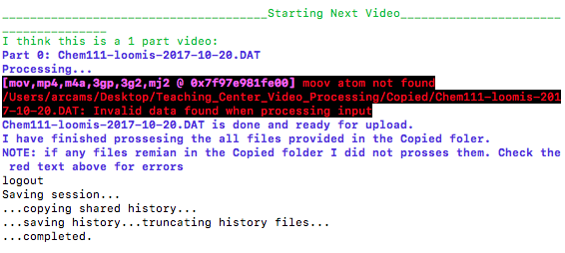Error with the underlying process (ffmpeg): In this example ffmpeg does not recognize the provided .DAT file. If you see any error like this double check for corrupt files. If you don’t know what the text means or how to fix the error please contact me and include a screen shot.
* Other Common Errors and how to deal with them:
  + If the script is closed before it is done processing videos it will leave a half encoded and corrupt file in the *Final* folder. If you notice corrupt files in the *Final* folder please delete them before you start the script
  + If the script is asking if you want to replace an already existing file it means one of two things. You are starting another instance of the script or a previous run of the script encoded or partially encoded the video.
    - If you are starting another instance of the script wait until the last one is finished.
    - Double check to see if the file is already done or if a corrupt file exists in the *Final* folder
  + Please let me know of any other things you notice and I will update this list

Last Update by Brenden Sweetman 10/26/17